🞂Sayed Ali Salman Mohammed

Contact No. **39382046** E-mail: **abu_alhasani@hotmail.com**

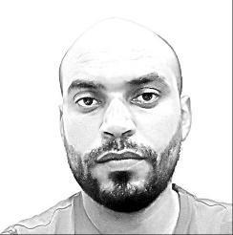Date of birth: 1-2-1979 Live in Al Qadam / Budaiya Road

Status: Married, I have got **3** Children

Certificates:

**Work experience:**

**Security Guard** in Awal Gulf for one year and four months, & in Eagle Security for one year and two months.

**Operator** in GIIC for five years.

**Admission Officer** in Bahrain Specialist Hospital for four years.

**Clearance Agent** as well as **Assistant Pablic Relation** in MRS fashion for six months.

**Cashier** in Alrahma Pharmacy for six months.

First Diploma in Mechanical & Planet Engineer, I got it in 2001 by BTI.

Secondary in Electrical, I got it in 1999 by Jidhafs Secondary School.

Educations:

MCP, MCSA & MCSE, I got them in 2002 by BIT.

Master in Microsoft Office 2000, I got it in 2001 by BIT.

Courses:

Professional Solving Skills, NLP & Customer Care

* By Horizon HRD

Performance Devlopment

* By Delmon Academy

Diploma in the Art and Science of Neuro Linguistic Programming

* By HRD Academy

Diploma in Installing Premises Cabling Systems

* By AMP

**And other courses**

Languages:

Fluent in Arabic

Good in English

Hobbies:

I interested in reading, walking & watching TV.